Short Courses offered
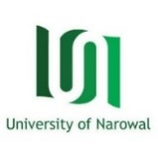
University of Narowal
Registration Form

Personal Information:
Picture required here
Name: _____________________________________
Father’s Name: _____________________________
Qualification: _______________________________
CNIC: _____________________________________
Contact No. 1: _________________
2: _________________
Email: ________________________
Address: _________________________________________________________
_________________________________________________________________

Courses: (Tick your courses)
- Certificate in Drawing & Painting

Applicant’s Signature: _______________
*Note:
- The short courses are not offered online.
- Minimum required qualification is Matric.
- Attach copies of CNIC & Matric certificates
For further Information: Visit/Contact Department of Fine Arts, University of Narowal

