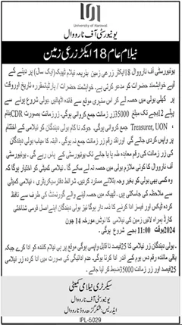

**Duniya News: 31-May-2024**

[**https://e.dunya.com.pk/news/2024/May/2024-05-31/GUJ/x321321_11973410.jpg.pagespeed.ic.Pr9jpmlOi2.webp**](https://e.dunya.com.pk/news/2024/May/2024-05-31/GUJ/x321321_11973410.jpg.pagespeed.ic.Pr9jpmlOi2.webp)